Instructor: John Beswetherick
Course: BUSIT 202
From: Christopher Singleton
Subject: Assignment3 – Working with Periodic Snapshots Fact
Date: 01/23/2016

Cover Memo
a.
The purpose of this assignment is to understand an inventory model design, which is concept of an inventory periodic snapshot fact.
This periodic snapshot covers logic modeling. Logic modeling includes how to define each measure that should be in the fact table according to the business user’s needs, that is a Key Performance Indicator (GMROI).
Based on the Northwind OLTP data, this assignment also includes the sample data of the semi-additive fact inventory snapshot (a point in time). The measure can be additive if it is aggregated by stores or products, but not by dates. The snapshot can be taken at the end of the day, end of the week, end of the month, and/or even end of the year, the measure (such as quantity on hand) is not additive because quantity on hand cannot be aggregated over a period of time. So, the fact is semi-additive.
In the beginning, one of the main problems was deciding how I was going to set up the fact table, but after looking at the calculations, it made common sense that I would be using the constituents of the calculations for the requirements as the measures in the fact table columns.
The reason of why I included a [Dim Store] table is that if they wanted to expand to having other stores in the future, otherwise it is not needed nor would it change anything with having just one store.

Snapshot Data Mart
b.
The reason of why I came up with this very basic logical design is because it meets all the requirements in doing the calculations for (GMROI) Gross Margin Return On Investment. This design is also very easy to explain to the end user of what is going on and how it fits in with getting all the (KPI’s) Key Performance Indicators. All the measures in the [Fact Inventory Snapshot] table can be calculated directly on the fly with the interconnecting tables that satisfy the minimum requirements in being able to retrieve all the data needed for GMROI. The end users can have their analysis of all measures by products or/and date. The [Dim Store] table allows for expandability in the future for other store locations, otherwise it is not needed nor would it change anything. The end user can easily get all the measures sliced by product and/or dates.

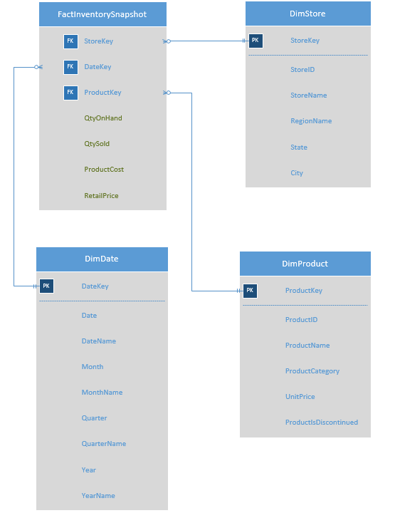

c.
This is an example daily snapshot of inventory at the end of one day. In the table below, please note that the [Unit Price] is the same as the [Product Cost] and the [Retail Price] is two times the [Product Cost]. The reason why the [Date Key] and [Product Key] have so many zeros, is that this allows capability for many rows. The [Store Key] with many zeros allows you to expand with having a great amount of stores and doesn’t make any difference with just one store, but allows you to track inventory from other stores if needed.

FactInventorySnapshot (Daily)
StoreKey | DateKey | ProductKey | QtyOnHand | QtySold | ProductCost | RetailPrice
00001 | 00001 | 00001 | 39 | 0 | 18.00 | 36.00
00001 | 00002 | 00002 | 17 | 40 | 19.00 | 38.00
00001 | 00003 | 00003 | 13 | 70 | 10.00 | 20.00
00001 | 00004 | 00004 | 53 | 0 | 22.00 | 44.00
00001 | 00005 | 00005 | 0 | 0 | 21.35 | 42.70
00001 | 00006 | 00006 | 120 | 0 | 25.00 | 50.00
00001 | 00007 | 00007 | 15 | 0 | 30.00 | 60.00
00001 | 00008 | 00008 | 6 | 0 | 40.00 | 80.00
00001 | 00009 | 00009 | 29 | 0 | 97.00 | 194.00
00001 | 00010 | 00010 | 31 | 0 | 31.00 | 62.00
00001 | 00011 | 00011 | 22 | 30 | 21.00 | 42.00
00001 | 00012 | 00012 | 86 | 0 | 38.00 | 76.00
00001 | 00013 | 00013 | 24 | 0 | 6.00 | 12.00
00001 | 00014 | 00014 | 35 | 0 | 23.25 | 46.50
00001 | 00015 | 00015 | 39 | 0 | 15.50 | 31.00
00001 | 00016 | 00016 | 29 | 0 | 17.45 | 34.90
4 + 4 + 4 + 4 + 4 + 8 + 8 = 36 bytes
Calculations: (integer = 4 bytes, Decimal (18, 4) = 8 bytes)
Numerator = (Product 1 quantity sold) * (Product 2 retail price – product 1 cost) +
(Product 2 quantity sold) * (Product 2 retail price – Product 2 cost)
Denominator = (Product 1 quantity on hand at end of day * Product 1 retail price) +
(Product 2 quantity on hand at end of day * Product 2 retail price)

Estimation of the size of the fact table: (each row = 36 bytes)
16 rows per day;
16 * 36 bytes = 576 bytes per day
Daily Snapshot - 30 days per month.
Size for two month worth of data:
576 * 2* 30 = 34560 bytes

(Continued)
Size for 1 year worth of data (first 2 month data is a Daily Snapshot; last 10 month data are Weekly Snapshots)
52 weeks per year;
9 weeks for the first 2 months (January to February);
43 weeks for the last 10 months (March to December);
16 rows per week;
16 * 36 bytes = 576 bytes per week;
Weekly Snapshot – 43 weeks for 10 months.
576 * 43 = 24768 bytes
Size for 1 year worth of data:
34560 bytes + 24768 bytes = 59328 bytes

d.
Assume that the data is for 1 store. This does not change the design (no store dimension needed). If the Northwind retailer gets very successful in the future, the store dimension should be added because the end users can do their analysis by stores when they have more stores in the future. I have added this dimension in my project/design for the future preparation.

